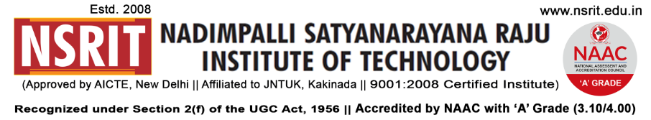SONTYAM, ANANDAPURAM, Visakhapatnam-531173

NSRIT /CIRCULAR/2019-20/104 Date: 17-12-2019

**CIRCULAR**

Faculty and staff members are expected to dress in a professional and appropriate manner. Proper grooming and attire have a positive impact on the teaching and learning environment.

Faculty members need to dress professionally and observe the faculty dress code guidelines as follows:

**Gents**: Formal neat shirts and pants, Shirts properly tucked in and shoes. Wearing ID cards,

Letting them out.

**Ladies:** Formal S aree Wearing ID cards

**D:\suresh sr off asst\SEEN\miscellaneous\HOD SIGNATURES\signature of rajasekharam(CSE).JPG**

**PRINCIPAL i/c**

Copy to

1. Secretary**:** for kind information.
2. Correspondent: for kind information.
3. A.O for information
4. **All** **HODs – CE/EEE/ME/ECE/CSE/S&H/MBA/DIP/OIE/LIB/PD**: for information and circulation among all the staff members.