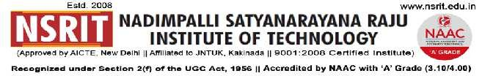

**SONTYAM, ANANDAPURAM, Visakhapatnam-531173**

NSRIT /CIRCULAR/2019-20/107 Date: 31-12-2019

**CIRCULAR**

All the staff members are hereby informed that the college will work on 01.01.2020 (Wednesday) from 09.00 AM to 12.30 PM.

A lecture by a Senior Professor has been scheduled at 09.30 hrs at Block-1 Seminar Hall. All faculty to attend positively.

Transport arrangement, as given below has been made for all staff members.

“**WISHING YOU AND YOUR FAMILIES A VERY HAPPY NEW YEAR 2020**”

**Principal**

Copy to

1. Secretary**:** for kind information.
2. Correspondent: for kind information.
3. A.O: for information
4. **All** **HODs–CE/EEE/ME/ECE/CSE/S&H/MBA/DIP/OIE/LIB/PD/ACC/HOSTEL(B/G)**: for information.

|  |  |  |  |  |  |  |  |  |  |  |
| --- | --- | --- | --- | --- | --- | --- | --- | --- | --- | --- |
| **CE** | **EEE** | **ME** | **ECE** | **CSE** | **S&H** | **MBA** | **DIP** | **OIE** | **LIB** | **PD** |
|  |  |  |  |  |  |  |  |  |  |  |

The buses schedule and route details exclusively for staff members are as follows:

|  |  |
| --- | --- |
| **Route – 1**  **E-Bus** | Start Time : 07.30 AM – Gajuwaka - BHPV – NAD – Gopalapatnam – Simhachalam – Advivaram - NSRIT. |
| **Route – 2**  **D-Bus** | Start Time : 07.30 AM – Akkayyapalem – Kancharapalem - R&B – NAD – Vepagunta - Sujatha Nagar – Pendurthi - NSRIT. |
| **Route – 3**  **H-Bus** | Start Time : 07.30 AM – Satyam Jn., - Seethammadhara – Venkojipalem – Dairy Form – Yendada – Madhrawada – Anandapuram - NSRIT. |