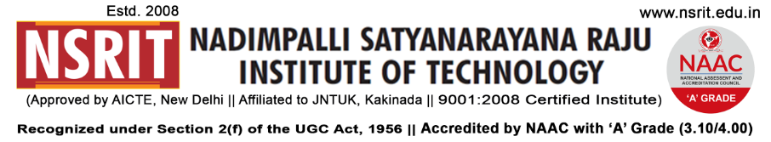SONTYAM, ANANDAPURAM, Visakhapatnam-531173

NSRIT /CIRCULAR/2019-20/115 Date: 29-01-2020

**CIRCULAR**

The college observes holiday on 08-02-2020 (Saturday) on account of **“Second Saturday”** for all students.

Parents meeting will be conducted on 08.02.2020 (Saturday) from 09.00 am for all the parents of B.Tech – I, II, III & IV year & Diploma I, II & III year students.

The transport arrangement on 08.02.2020(Saturday), as given below has been made for all staff members.

**PRINCIPAL**

Copy to

1. Secretary**:** for kind information.
2. A.O for information
3. **All** **HODs – CE/EEE/ME/ECE/CSE/S&H/MBA/DIP/OIE/LIB/PD**: for information and circulation among all the students.

|  |  |  |  |  |  |  |  |  |  |  |  |
| --- | --- | --- | --- | --- | --- | --- | --- | --- | --- | --- | --- |
| **Class Rooms** | | | | | | | | | | | |
| **Section** | **Staff** | **Student** | **Section** | **Staff** | **Student** | **Section** | **Staff** | **Student** | **Section** | **Staff** | **Student** |
| I CSE-A |  |  | II CE |  |  | II ME-A |  |  | II ECE |  |  |
| I CSE-B |  |  | III CE |  |  | II ME-B |  |  | III ECE |  |  |
| I ECE-A |  |  | IV CE |  |  | III ME-A |  |  | IV ECE |  |  |
| I ECE-B |  |  | II EEE |  |  | III ME-B |  |  | II CSE |  |  |
| I CE+EEE |  |  | III EEE |  |  | IV ME-A |  |  | III CSE |  |  |
| I ME |  |  | IV EEE |  |  | IV ME-B |  |  | IV CSE |  |  |
| I DME-A |  |  | III DME-A |  |  | I DEEE |  |  | I MBA-A |  |  |
| I DME-B |  |  | III DME-B |  |  | II DEEE |  |  | I MBA-B |  |  |
| II DME-A |  |  |  |  |  | III DEEE |  |  | II MBA |  |  |
| II DME-B |  |  |  |  |  |  |  |  |  |  |  |

The buses schedule and route details exclusively for staff members are as follows :

|  |  |
| --- | --- |
| **Route – 1**  **- Bus** | Start Time : 07.30 AM – Old Gajuwaka - NAD – Gopalapatnam – Vepagunta -Sujatha Nagar - Pendurthi - NSRIT (Incharge : P.Gurunath - 9885991996). |
| **Route – 2**  **- Bus** | Start Time : 07.30 AM – R&B - Akkayyapalem – Kancharapalem – Gurudwara – Satyam Jn., - Maddilapalem – Dairy Form – Yendada – Madhurawada – Anandapuram – NSRIT (Incharge : K.Ram Prasad – 7569323977). |

-----------------------------------------------------------------------------------------------------------------------------

Copy to: CTO: He is requested **to operate** 2 busses on 08-02-2019 (Saturday).

-----------------------------------------------------------------------------------------------------------------------------