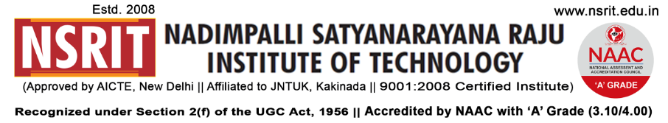SONTYAM, ANANDAPURAM, Visakhapatnam-531173

NSRIT/CIR/staff/2018-19/27 Date: 04.09.2018

**CIRCULAR**

The Chairman, Secretary and Principal, NSRIT, Sontyam take pleasure in Wishing all Faculty a **Very Happy TEACHERs DAY.** We are very proud to have a set of dedicated, competent and expert Teachers with NSRIT who are instrumental in guiding students, updating their technical skills by sharing knowledge with students and taking care of the students in all dimensions.

On this occasion, a gathering of all Staff is scheduled at Seminar Hall-I on 05/09/2018 at 9.10 am to celebrate **birthday of “Dr. Sarvepalli Radhakrishnan”**. Those who are not having class work are requested to attend the function.

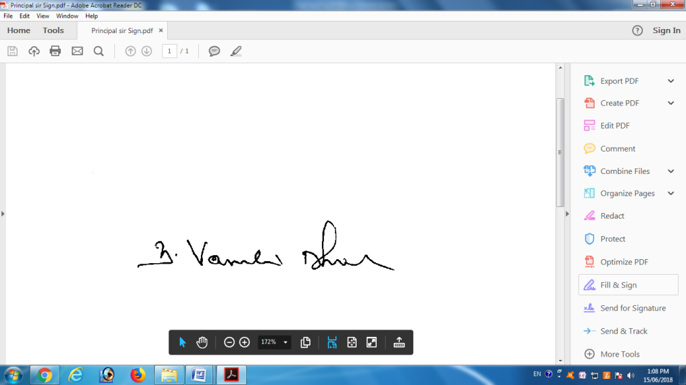

**PRINCIPAL**

Copy to

1. Secretary**:** for kind information.
2. Correspondent: for kind information.
3. A.O for information
4. HOD **–** S&H/MBA/CIVIL/EEE/ME/ECE/CSE/OIE/DIP/PD/Lib/Accounts/Transport –

for information and circulation to all students.