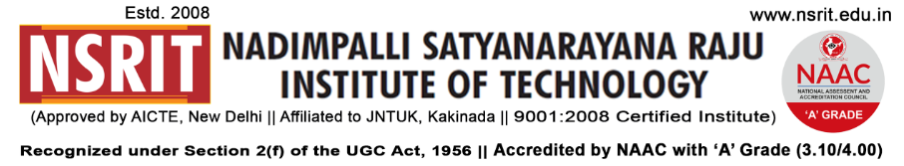

SONTYAM, ANANDAPURAM, Visakhapatnam-531173

NSRIT /CIR/staff/2018-19/32 Date: 07-09-2018

**CIRCULAR**

All the Staff members are hereby informed that “**NCL**” (**NSRIT Cricket League)** will be conducted on **08-09-2018 (Saturday) at 09.30 AM** in our college ground. Staff members can attend the Cricket Tournament.

FN Session : IV-CSE Vs I-CSE

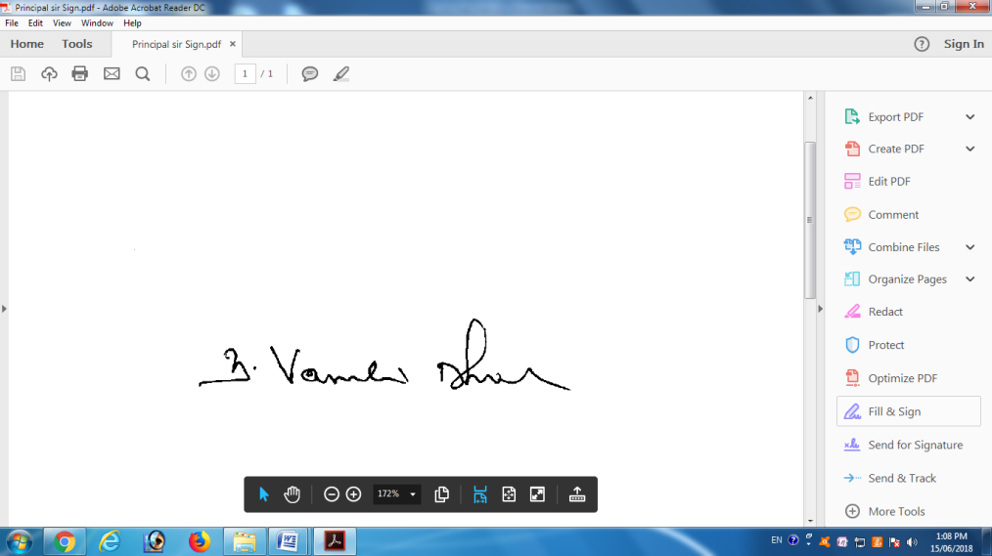AN Session : IV-ME-`A` Vs IV-ME-`B`

**PRINCIPAL**