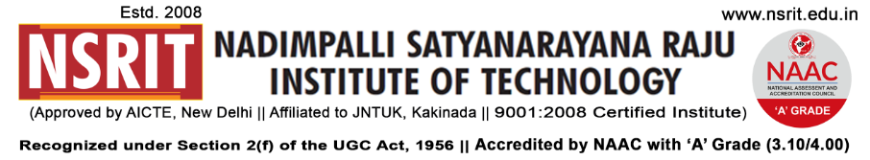SONTYAM, ANANDAPURAM, Visakhapatnam-531173

NSRIT/CIR/staff/2018-19/34 Date: 12.09.2018

**CIRCULAR**

The Institute will observe holiday on 13-09-2018 (Thursday) on account of **“VINAYAKA CHAVITHI ”.**

**PRINCIPAL**

Copy to

1. Secretary**:** for kind information.
2. Correspondent: for kind information.
3. A.O for information and necessary action.
4. HOD **–** S&H/MBA/CIVIL/EEE/ME/ECE/CSE/OIE/DIP/LIB/Accounts/Reception/PD/Chief Transport Officer – for information and circulation to all students.

|  |  |  |  |  |  |  |  |  |  |  |  |  |  |
| --- | --- | --- | --- | --- | --- | --- | --- | --- | --- | --- | --- | --- | --- |
| S&H | MBA | CIVIL | EEE | ME | ECE | CSE | OIE | DIP | LIB | Accounts | PD | CTO | Canteen |
|  |  |  |  |  |  |  |  |  |  |  |  |  |  |

---------------------------------------------------------------------------------------------------------------------

Copy to: Transport In-charge: He is requested **not to operate** busses on 13-09-2018. **All the services may be operated as usual from 14-09-2018**.

---------------------------------------------------------------------------------------------------------------------

**\*\*\***