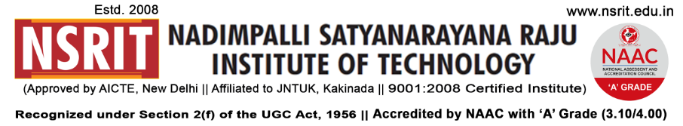SONTYAM, ANANDAPURAM, Visakhapatnam-531173

NSRIT/CIR/staff/2018-19/37 Date: 20.09.2018

**CIRCULAR**

The Institute will observe holiday on 21-09-2018 (Friday) on account of **“MUHARRAM”.**

**PRINCIPAL**

Copy to

1. Secretary**:** for kind information.
2. Correspondent: for kind information.
3. A.O for information
4. HOD **–** S&H/MBA/CIVIL/EEE/ME/ECE/CSE/OIE/DIP/PD/Lib/Accounts/Transport/Canteen/Hostels

for information and circulation to all students

|  |  |  |  |  |  |  |  |  |  |  |  |  |  |  |  |
| --- | --- | --- | --- | --- | --- | --- | --- | --- | --- | --- | --- | --- | --- | --- | --- |
| S&H | MBA | CIVIL | EEE | ME | ECE | CSE | OIE | DIP | LIB | Accounts | PD | CTO | Canteen | Hostel | |
|  |  |  |  |  |  |  |  |  |  |  |  |  |  |  |  |