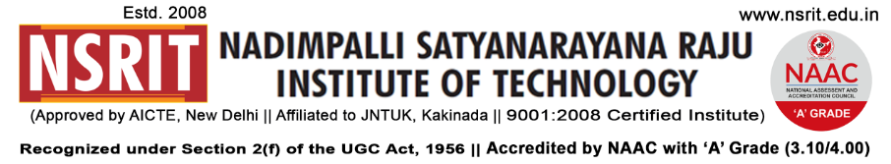SONTYAM, ANANDAPURAM, Visakhapatnam-531173

NSRIT/CIR/staff/2018-19/39 Date: 01.10.2018

**CIRCULAR**

The Institute will observe holiday on 02-10-2018 (Tuesday) on account of **“GANDHI JAYANTHI ”.**

On this occasion Secretary sir will garland the Gandhiji statue at 9.00 am, hence all the HODs and senior staff are requested to attend the garlanding programme followed by breakfast.

**PRINCIPAL**

Copy to

1. Secretary**:** for kind information.
2. Correspondent: for kind information.
3. A.O for information
4. HOD **–** S&H/MBA/CIVIL/EEE/ME/ECE/CS E/OIE/DIP/PD/Lib/Accounts/Transport –

for information and circulation to all students